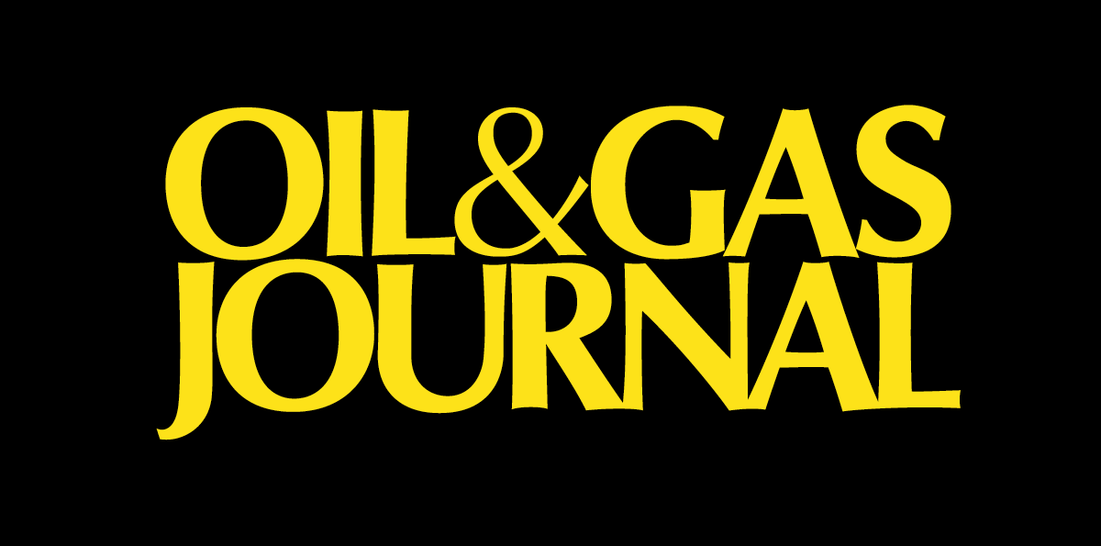

PennWell Petroleum Group
ONLINE MARKETING

Webcast Marketing Packages
- Increase sales leads and awareness from a targeted online audience of industry professionals who have pre-registered for your presentation.
- Highly effective method to announce new products or services, conduct round-table discussions,gain qualified sales leads, etc.
- Access to contact information for all registered users of your webcast.
- 1-month of pre-event online marketing, 60 minute LIVE webcast plus a 12-month archive of your webcast on our website.
- See the 10-minute demo “Webcast on Webcasts” which overviews the technology & marketing
- Click here to view : http://w.on24.com/r.htm?e=2692&s=1&k=50636FD24D55CE3962F945CF322C0353

Website Banner Advertising - www.ogjonline.com
- Increase awareness to over 53,000 monthly visitors: Branding / Impressions / Click-thru’s
- Targeted banner positions to specific reader content. Large banner ad sizes.
- NEW! Post up to 15 White Papers! Home Page White Paper section with link to your company bio, banner & White Papers. Highly qualified leads as viewers register to download your White Paper.
- Web site traffic – Home Page – Average Per Month: Page Views: 94,339 Visits: 53,788

Targeted e-List Rentals and Blasts
- Target segments of the 17,000+ Oil & Gas Journal opt-in subscribers with a custom e-mail marketing message (i.e. show specials before major tradeshows, newsletter, product/service information, seminar promotion)
- Selects available by title, industry, operation, activity, geography and much more.

Newsletter Banner Sponsorships
- The Oil & Gas Journal DAILY and Oil & Gas Journal Weekly E&D Report both deploy to over 30,000 opt-in subscribers. Targeted industry intelligence selected & written by Editors of OGJ. Only 5 large banner positions available per issue for maximum exposure.

Custom e-Mail Surveys
- Target segments of The Oil & Gas Journal subscribers with a blind or branded survey.
- Gain market intelligence and/or highly qualified sales leads

For more information please contact:
Mike Moss – Online Advertising Sales Director – Petroleum Group 713.963.6221 mikem@pennwell.com

